
Deliverable number: (D.4.1)
Author(s): Andrew King
Author'(s') affiliation: Energy Saving Trust

National report on end-users decision making factors on H&C systems

UK: NATIONAL REPORT

KEY DECISSION FACTORS

CONTENTS
1. OBJECTIVE 3
2. surveys in the UK 3
3. survey on residential sector 4
3.1 Main characteristics of the sample 5
3.2 current heating and cooling systems 6
3.3 Information resources 7
3.4 Key Purchasing Criteria 8
3.5 AWARENESS ABOUT RHC 10
3.6 Perception of RHC attributes 10
3.7 Adequacy of Renewable Energy Solutions 11
3.8 Willingness to Pay 12
4. Survey on non-residential sector 14
4.1 Main Feartures of the sample 15
4.2.2 Current heating and cooling systems 16
4.3 Information sources 18
4.4 Key purchasing criteria 19
4.5 awarness about Rhc 21
4.6 PERCEPTION OF RES ATTRIBUTES 21
4.7 Willingness to pay 24
5. Survey on industrial sector 25
5.1 Main characteristics of the sample 26
5.2 CURRENT HEAT AND COOLING SYSTEMS 26
5.3 INFORMATION RESOURCES 28
5.4 Key purchasing criteria 29
5.5 Knowledge about RES 31
5.6 perception of res TECHNOLOGIES 32
5.7 Adequacy of Renewable Energy Solutions: 33

UK NATIONAL REPORT

Executive summary
The main objective of this report is to identify end-users’ decision making factors when making choices about renewable heating and cooling (RHC) systems in the UK. The surveys were split into three sections: residential, non-residential and industrial. The surveys addressed the heating and cooling sector as whole and not simply renewable energy solutions (RES). At the residential level, 532 interviews were conducted; at the non-residential level – 182 interviews were conducted, and at the industrial level 120 surveys were completed.
The residential survey revealed a high level of satisfaction with their incumbent fossil fuel systems. The most frequented source of information regarding RES solutions was the internet and the most important consideration when choosing a renewable technology was its reliability. Furthermore, there was a high level of awareness of RHC systems. Compared with fossil fuel alternatives, homeowners considered RHC technologies to have a higher initial investment but lower operational and maintenance costs.
The non-residential survey was mainly comprised of those dependent on natural gas and electric heating. At 90%, the levels of satisfaction were found to be particularly high for natural gas boilers. However, this figure dropped dramatically for oil and LPG gas boilers. Again the internet was considered as the most likely source of information for RHC systems and reliability ranked as the most important purchasing criteria. In line with the residential results, commercial premises considered RHC technologies to have a higher initial investment but lower operational and maintenance costs versus fossil fuel alternatives.
The large-scale industrial survey recorded high use of fossil fuels and satisfaction with their fuel type – with reliability and safety cited as key drivers. For those who had used cooling as part of their industrial process, electricity was the main source. For the industrial sector, information was predominantly sought from professionals and the key purchasing criteria for RHC systems was reliability and safety. Whilst overall awareness levels of RHC systems were high, there was a notable drop regarding district heating. In contrast to the residential and commercial sector, there were higher levels of awareness amongst renewable cooling systems. Solar water heating was recorded as the most suitable technology amongst respondents, and whilst initial investment was expected to be higher – operation and maintenance costs were expected to be lower.

OBJECTIVE
The objective of this report is to identify end-user decision making factors for renewable heating and cooling (RHC) systems in the UK. This will be the first step to build a greater understanding around the decision making process when consumers consider RHC systems. Furthermore, the results of the survey are expected to feed into the development of future tools, aimed at facilitating stakeholders at both the European and national level, to provide more effective and transparent information to consumers on RHC systems.
The surveys have sought to identify the key purchasing criteria (KPC) associated with RHC systems. They will also provide information on consumers’ “Willingness to pay”, including environmental and social parameters. The surveys have addressed the heating and cooling sector as a whole and not only the renewable energy solutions.
In order to develop a more complete understanding of the renewable heat and cooling (RHC), the surveys have been executed in three different sectors: residential, non-residential and large-scale industry.

surveys in the UK
To achieve this objective a national survey has been carried out by the Energy Saving Trust, the UK’s Energy Agency responsible for delivering impartial advice to homeowners and community organisations on how to reduce energy consumption within the domestic sector. For the purposes of this report, the Energy Saving Trust undertook the surveys in-house through trained advisors located in the Energy Saving Trust’s Welsh Advice Centre. The execution time of this activity, excluding the subcontracting launching period, was approximately two months
The number of queries in the UK by sector and the related representativeness were the following:

SECTOR | Number of queries | Population size | confidence level | sample error
Residential | 532 | 65,110,000 | 95% | 4.25%
Non-residential | 182 | - | 95% | 7.23%
Industry | 120 | - | 95% | 8.92%

survey on residential sector
The flow diagram in the execution of the survey is shown in Figure 1 and 2.
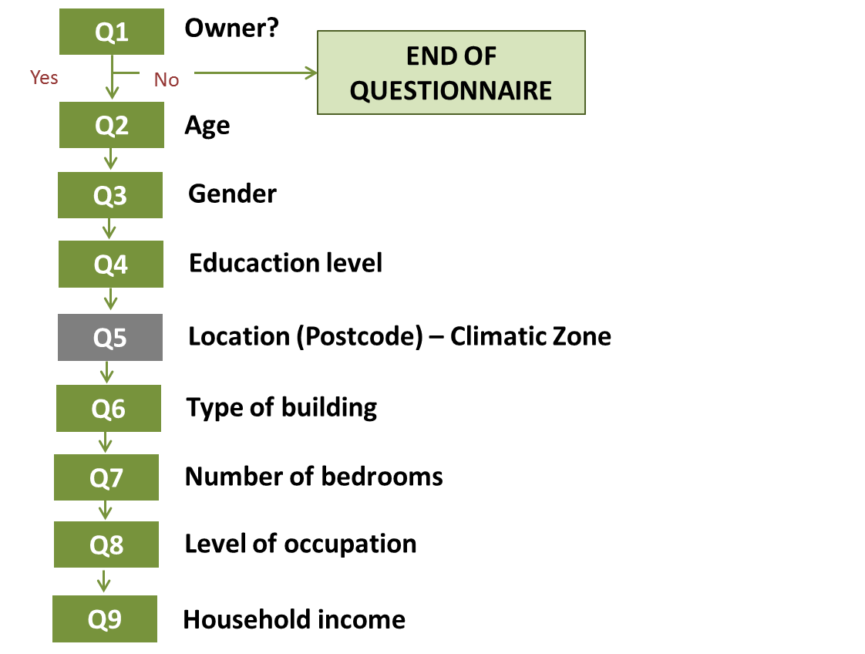
- Characterization of the sample
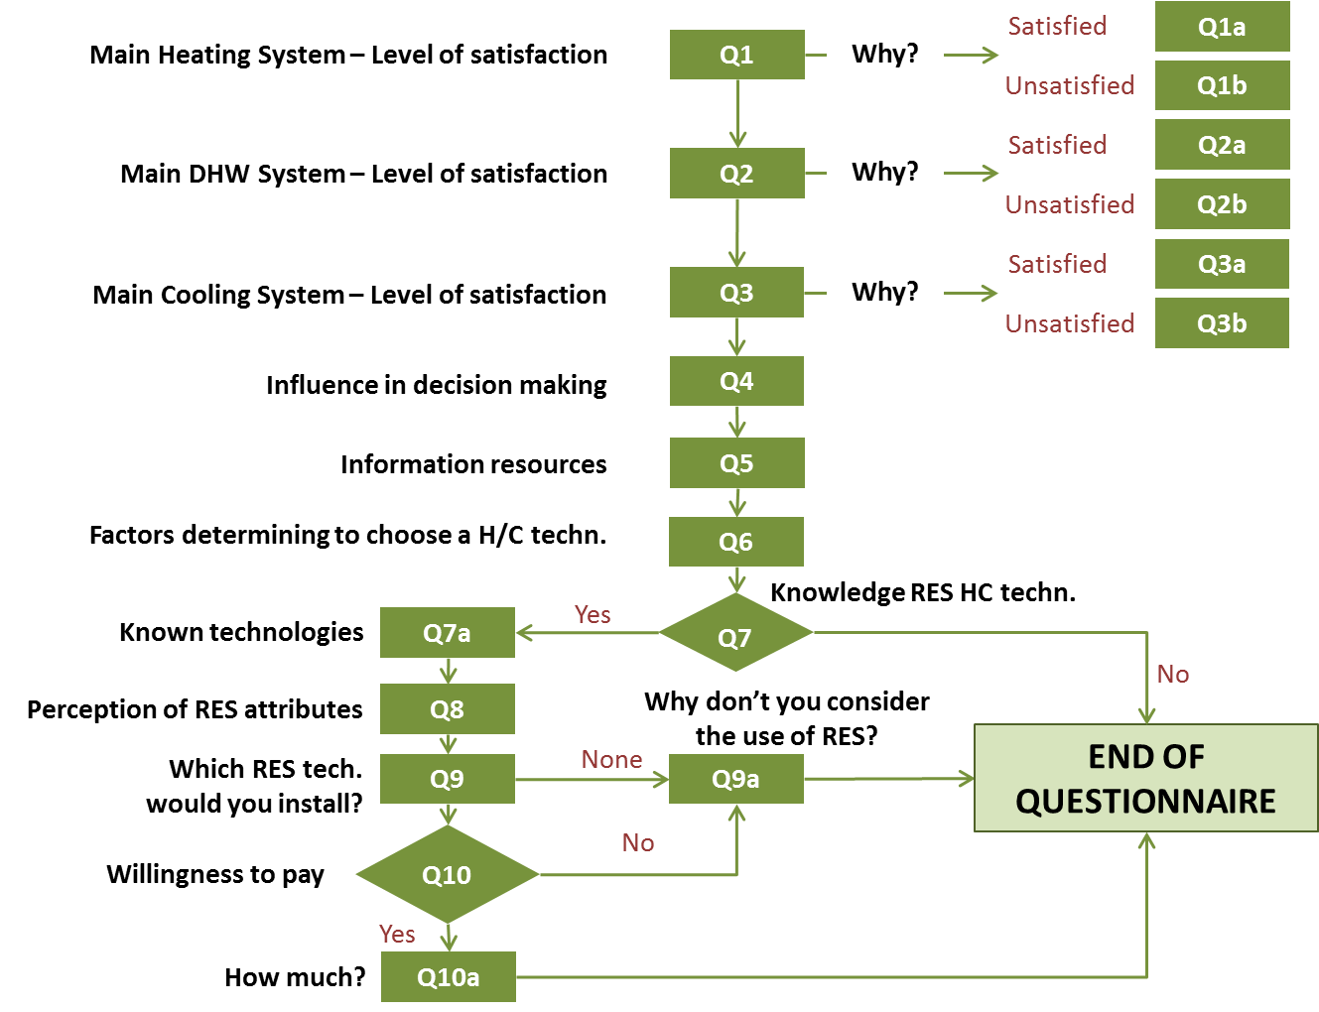
- Flow diagram to follow in questionnaires – residential sector.

Main characteristics of the sample
In the UK, 532 interviews were executed in the residential sector. The main characteristics of the sample are depicted in Figure 1. The sample is balanced comparing with the total data of the country

GENDER EDUCATION LOCATION
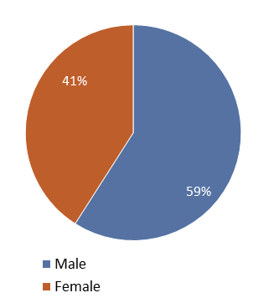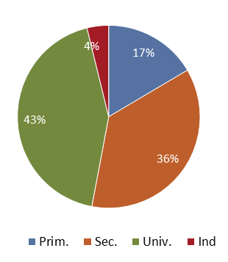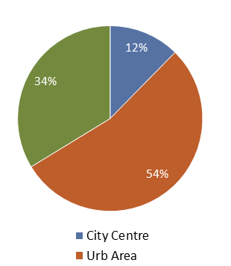

INCOME BUILDING TYPE No. of BEDROOMS
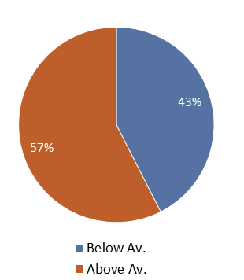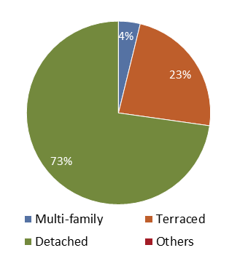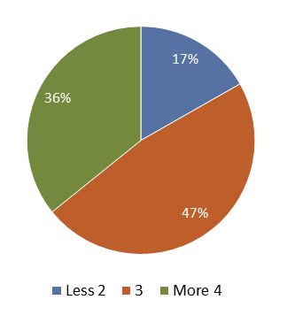

OCCUPATION AGE RANGE
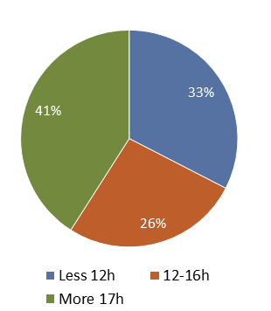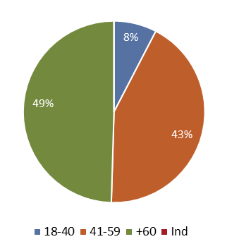

Figure 1 Characterization of the sample

current heating and cooling systems

67 % of the total respondents were dependent upon natural gas boilers as their primary form of heating. A further 14 % were reliant upon oil heated boilers, a figure that would be proportionate with respondents from rural areas. All the respondents, across all technologies, were noted to have decentralised systems - a figure that broadly reflects the UK’s current energy sector. Levels of satisfaction for homeowners with oil and natural gas boilers varied from 78% to 91% respectively.
Figure 2 Distribution of heating systems in the UK (residential sector).
Renewable energy systems accounted for only a small proportion of those surveyed, varying from one to three per cent. Whilst the sample size for renewables was relatively small, there were particularly high levels of consumer satisfaction associated with Air Source Heat pumps, recorded at 95%.
With regards to Domestic Hot Water systems (DHW), natural gas boilers again accounted for the majority of recorded systems, 66% in total. However, there was a notable decrease in LPG gas boilers used for DHW purposes, down to 1 %. Seven per cent of respondents were instead reliant on oil heated boilers and a further five per cent relied upon electric immersion heaters, the majority of these were unsurprisingly found in urban and city centre areas.
Figure 3 Distribution of DHW in the UK (residential sector).

Information resources
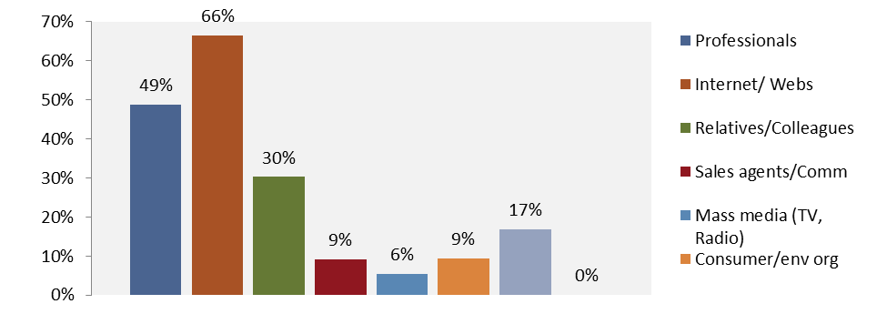
Figure 4 information sources in the UK
Recorded at 66%, the internet was found to be the highest source of information for people wishing to learn more about renewable heat and cooling technologies. This was followed by industry professionals and recommendations from friends or family - at 49% and 30% respectively. For the youngest proportion surveyed participants (18-40 years old) – an overwhelming majority, 83 %, were typically found to use the internet as their primary source of information source. However, for those who were aged 60 and over this figure fell to 57%. Conversely, the younger age sector was found to be approximately twice as likely to consult consumer or environmental organisations, versus the older generations.
In terms of gender there did not appear to be any discernable difference between the two sexes. However, in terms of income those who were identified as earning below the national average are less likely to use the internet as an information source versus higher earners, at 60% and 70% respectively.

Key Purchasing Criteria
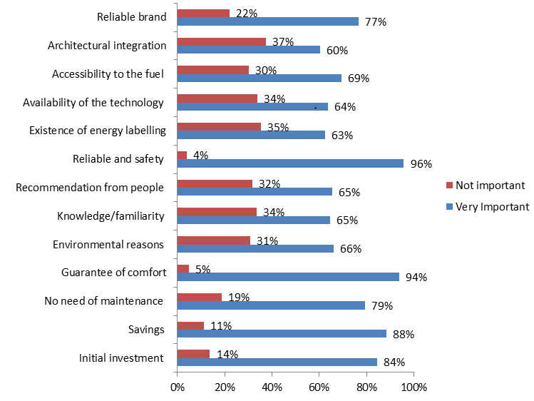
Figure 5 Key Purchasing criteria in the UK
Figure five indicates that at 96%, the ability for a technology to prove both reliable and safe, is seen as the most important factor when purchasing new heating or cooling equipment. The second most important factor highlighted was guarantee of comfort - at 94%. Whilst all of the above factors proved more important than not, it is worth highlighting that 37 % of those surveyed did not consider architectural integration as an important indicator.
Table one reveals the key decision factors broken down by demographic structure. In terms of gender, women were significantly more likely to seek recommendations from friends and colleagues, versus their male counterparts – at 73% and 59 % respectively. With regards to age, the younger demographic (18-40), were found to be less reliant on familiarity with a technology versus those who were aged 60 and over. With respect to education, 54% of those who had received primary form of education considered environmental reasons to be important. However, for those who had received further levels of education, either a university degree or higher, this figure increased to 76%. Lastly, in terms of earnings, those who were recorded as having a higher than average UK income, were notably more likely to place an emphasis on knowledge and familiarity of a technology before purchasing a renewable heat based solution.
Table 1: Key Decision Factors

AWARENESS ABOUT RHC
Table 2: awareness
Table two indicates that the vast majority of those surveyed were aware of Renewable Energy Technologies, at 79 %. With regards to age, awareness was higher amongst the older generations from 41 years old and above. Education also appears to be an important indicator in terms of awareness, which is noted to increase with higher levels of education. In terms of gender awareness of RES is found to be higher amongst men.
Out of the 79% of respondents who had heard of RHC solutions, table three breaks down the awareness of this sample set by technology type – split between heating and cooling options.

TECHNOLOGY | HEATING/DHW |  | COOLING
Solar water heating | 100% |  | 31%
Biomass | 100% |  | 32%
Heat pumps (Renewable) | 100% |  | 34%
Geothermal | 100% |  | 30%
Table 3: Awareness by technology type

Perception of RHC attributes

ATTRIBUTE | RENEWABLES | NON-RENEWABLES
Higher initial investment | 94% | 8%
Higher operation costs (maintenance and fuel) | 20% | 82%
Higher savings along the life expectancy of equipment | 86% | 15%
More eco-friendly | 97% | 5%
Higher working reliance | 60% | 47%
Higher visual impact and/or need of space to install/store fuel | 85% | 18%
Safer | 83% | 29%
More specialized installers | 93% | 12%
Table 4: awareness by technology type
Perhaps unsurprisingly higher initial investment costs were associated with renewable energy technologies, however, inversely higher operational costs including maintenance and fuel was associated with non-renewable energy technologies. The survey revealed that a higher working reliance was more closely related with renewable versus non-renewable energy technologies, at 60% versus 47% respectively. Furthermore, renewable energy technologies were seen to be significantly safer versus their counterparts.

Adequacy of Renewable Energy Solutions

Factor |  | Percentage
Expensive |  | 59%
Structural changes |  | 55%
Approval of neighbours |  | 10%
Climatic conditions |  | 7%
Difficult to find installers |  | 6%
Difficult to use |  | 5%
Maintenance costs |  | 4%
Not reliable |  | 1%

Table 5 Adequacy of RES
Of those surveyed who did not consider renewable energy technologies were suitable for their home, 59% felt that renewable energy technologies tended to be too expensive. The second highest cited factor was the issue of potential structural changes required to the property.
Suitability of RES for home
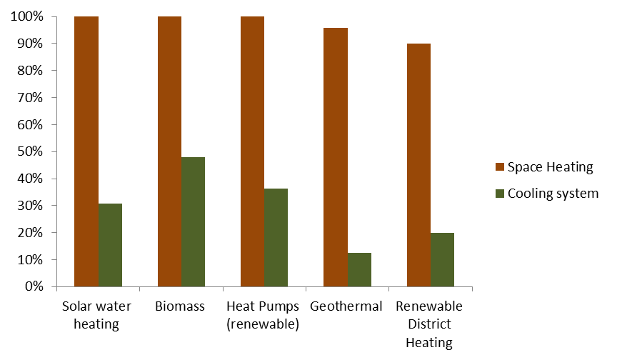
Figure 6: Suitability of RES for the home

Figure six highlights the high degree of considered suitability across all the listed renewable energy technologies, with only geothermal and district heating receiving a slightly lower response rate. However, for cooling systems the level of awareness across all the listed technologies is significantly lower and maybe indicative of the fact that these technology types are less well suited and prevalent within the UK domestic sector.

Willingness to Pay
When respondents were presented with the fact that initial investment in RES tended to be higher versus fossil fuel alternatives, would they still be willing to invest? 68% of those surveyed answered ‘yes’, a further 27 % said ‘no’ and 5% stated that they were not sure.
The following breakdown reveals how much more participants were willing to pay versus fossil fuel alternatives.

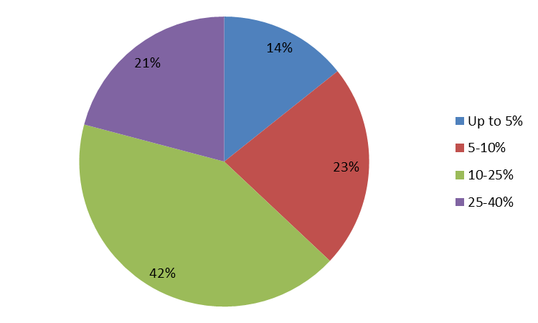
Figure 7; suitability of RES for the home
However, in terms of gender it was found that women were marginally less likely to pay a higher initial investment versus their male counterparts. This was particularly noted in the ‘up to 5%’ range, which was recorded at 12% (male) versus 20% (female). Nevertheless, the ‘10-25%’ initial investment scenario was counted as the most frequently answered option for both male and female, at 43% and 44% of overall gender specific responses.

Survey on non-residential sector
The flow diagram in the execution of the survey is shown in Figure x and x.
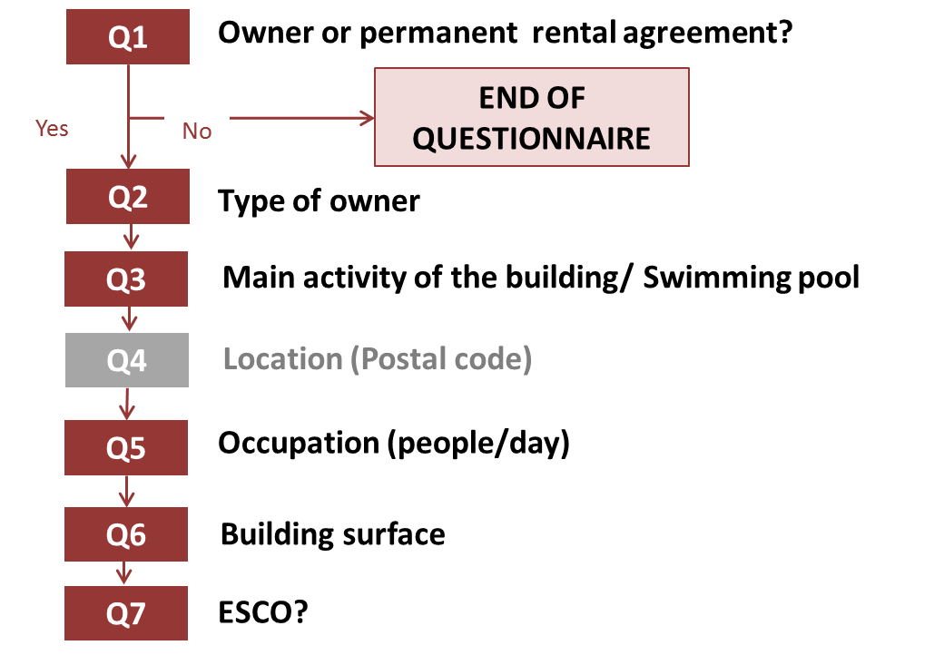
Flow diagram; Characterization of the sample
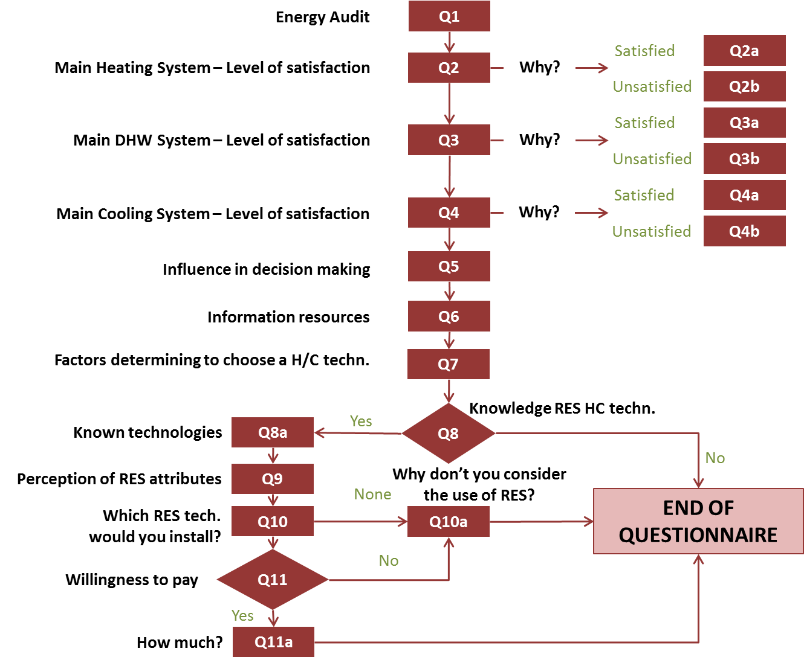

Flow diagram; questionnaire routes – non-residential sector.

4.1 Main Feartures of the sample
Within the UK there were 182 surveys conducted in the non-residential sector. The main characteristics of this sample set are outlined in Figure 8.

BUILDING OWNER POOL ESCO
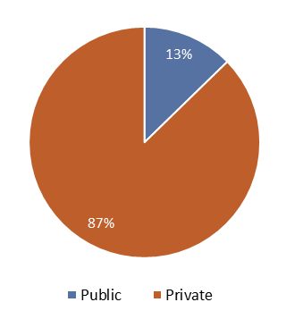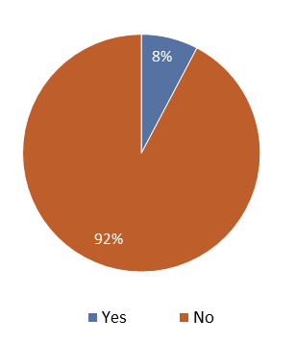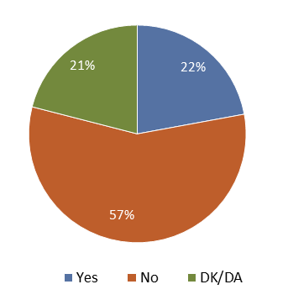

ENERGY AUDIT MAIN ACTIVITY
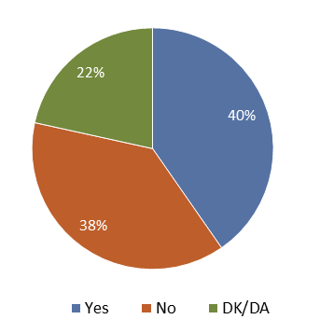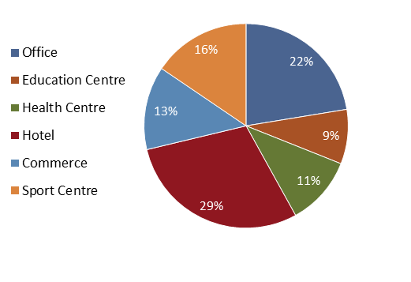

Figure 8: Characterization of the sample in non-residential sector.

4.2.2 Current heating and cooling systems

Figure 9: breakdown of space heating systems, non-residential sector

Sixty per cent of the space heating systems surveyed were natural gas boilers, whilst electric space heating systems (including oil radiators) accounted for 19%. Renewable energy systems featured less in the survey. Of these biomass systems were the most popular at 7%, a figure that perhaps reflects the popularity of this technology under the Renewable Heat Incentive. Solar thermal, ground and air source heat pumps featured significantly less in the survey, accounted for between 1-2% of surveyed systems.

At 90%, the levels of satisfaction were found to be particularly high for natural gas boiler. However, this figure dropped dramatically for oil and LPG gas boilers – at 54% and 50% respectively. For respondents who were reported as being ‘satisfied’ with their system, the majority (34%) cited ‘Good levels of thermal comfort’ as their principle reason. System reliability and initial investment costs were recorded as the second and third most important reasons, at 24% and 17% respectively. It is worth noting that only 4% of respondents who stated that they were satisfied with their system cited environmental reasons as the key factor. Conversely for those who were dissatisfied with their system, the cost of fuel and low levels of thermal comfort were cited as the two most common stated reasons, at 35% and 30% respectively.
Figure 10: distribution of water heating systems, non-residential sector

For water heating systems, natural gas boilers were recorded as the most frequent system type at 60%; followed again by electric heating systems at 21% and heating oil boilers at 8%. In line with space heating systems, biomass boilers were recorded as the most common renewable energy option, with 5 % of total responses - followed by solar thermal and heat pumps at 2% and 1% respectively. There were no recorded instances of district heating systems, either renewable or non-renewable.
Levels of satisfaction for the hot water systems were again high for natural gas boilers, with 89% of respondents stating that they were ‘satisfied’ with their system. Electric hot water systems also recorded high levels of end-user satisfaction at 73%. However, for respondents who had oil boilers, levels of satisfaction fell to 67%. For biomass systems, 80% of end-users were reported as being satisfied with their system.
Electric air-conditioning units were the primary technology type recorded for cooling purposes in commercial buildings, accounting for 93% of total responses. For this technology, respondents recorded relatively high levels of satisfaction at 84%.
On average, when respondents were questioned why they had installed either their space heating or cooling system, 85 % stated that other persons had already taken the decision. The joint second most cited reason, at 80%, was ‘familiarity with the technology’ and ‘access to a cheap fuel supply’. The availability of soft loans or subsidies did not rank highly as cited reason, with 56% of recorded responses. On average for both space heating and hot water systems, 45% of respondents cited ‘a lack of awareness of other technologies’ as the least selected reason.

4.3 Information sources
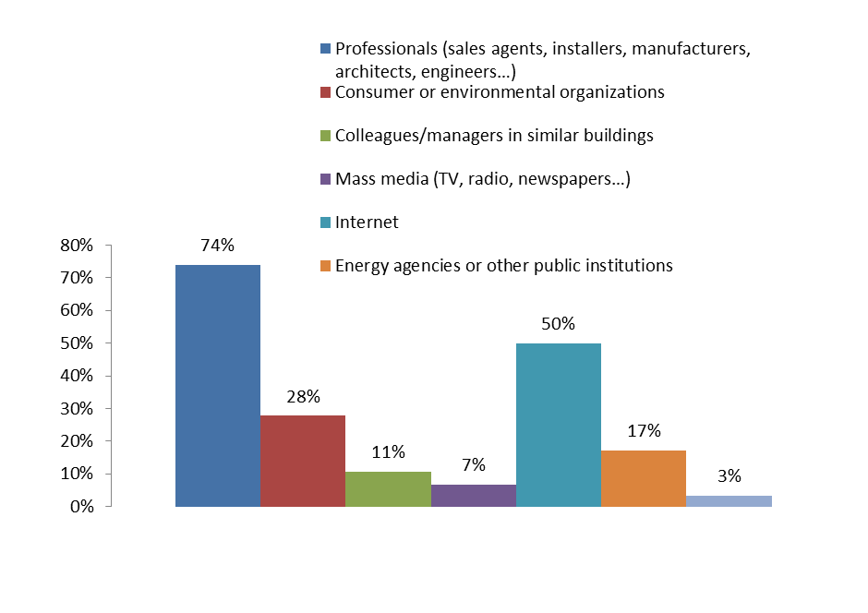
Figure 11: Information resources in the UK
With 74 % of total responses, professionals (including: installers, manufacturers, architects and engineers), were seen as the principle source of information when deciding on a new space heating or hot water system. Fifty per cent of respondents also cited the internet has a key information source. Colleagues and mass media were the least favoured options, at 11% and 7% respectively.

Given that the majority of respondents were from the private sector (87%), we have been unable to understand how ownership type relates to information sources. However, in terms of building type, education centres were found to be particularly reliant upon professionals for information; and health centres, were found to be dependent upon the internet and professionals, as their main information source. This pattern is repeated for both office buildings and sports centres. In contrast, hotels were recorded to be proportionally more reliant upon consumer organisations for information versus other building types.

4.4 Key purchasing criteria
According to the UK survey the key purchasing criteria (KPC) for space heating, hot water and cooling systems in the non-residential sector are:

Figure 12: Key Purchasing Criteria, non-residential sector

Reliability (93%), guarantee of comfort (88%) and savings along the life expectancy of the equipment (88%) were identified as the most important KPCs - a reflection of the UK’s domestic energy survey. It is worth noting that environmental reasons and existence of energy labelling, were both considered to be one of the least important KPCs; each accounting for 69% of respondents - again a trend that was previously reflected in the UK domestic survey. Architectural integration was recorded as the least important KPC.

The following table provides an outline of the KPCs broken down per property type, ownership and whether a pool is present. Whilst it hasn’t been possible to draw conclusions between ownership type, table six reveals education centres strong propensity to rely on thermal performance and cost of maintenance as valuable KPC’s. Guarantee of comfort is routinely highlighted as an important KPC across all building types. Environmental reasons are found to be less important across all building types, except for office buildings; and the hotel sector is found to place significantly less reliance on architectural integration and availability of technology versus other property types.

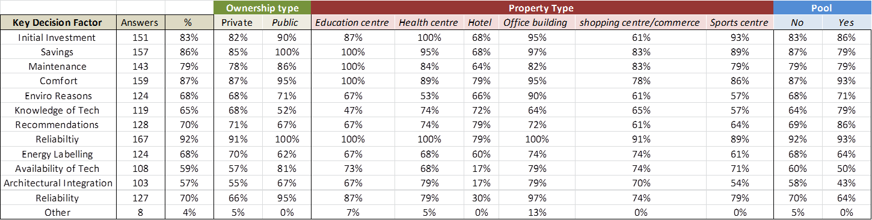

Table 6: Key Purchasing Criteria, non-residential sector

4.5 awarness about Rhc
69% of respondents had heard of renewable energy technologies, either for heating or cooling purposes. The following table outlines the knowledge about RES, considering the characteristics of the sample. The deviation of each characteristic compared with the distribution of the number of answers is shown:

Table 7: awareness of RHC by area of activity

The known technologies for those who have heard about RES (81%) of the survey respondents are represented in the following table:

TECHNOLOGY | HEATING/DHW |  | COOLING
Solar thermal | 100% |  | 23%
Biomass | 100% |  | 19%
Heat pump (renewable) | 100% |  | 29%
Geothermal | 100% |  | 23%
District Heating (renewable) | 100% |  | 19%

Table 8: awareness of RHC systems by technology type

4.6 PERCEPTION OF RES ATTRIBUTES
In terms of perception, renewable heat and cooling technologies are considered to have a higher initial investment but lower operational costs versus non-renewable alternatives. Furthermore, renewable energy options are perceived to deliver higher savings during the life expectancy of the equipment. However, with regards to working reliance, there is a relatively even split between renewable and non-renewable energy technologies.

ATTRIBUTE | RENEWABLES | % | NON-RENEWABLES | %
Higher initial investment | 113 | 90% | 12 | 10%
Higher operation costs (maintenance and fuel) | 36 | 29% | 89 | 71%
Higher savings along the life expectancy of equipment | 106 | 87% | 16 | 13%
More eco-friendly | 124 | 99% | 1 | 1%
Higher working reliance | 69 | 57% | 53 | 43%
Higher visual impact and/or need of space to install | 109 | 88% | 15 | 12%
Safer | 109 | 84% | 20 | 16%
More specialized installers | 110 | 92% | 10 | 8%

Table 9: characteristics associated with renewable and non-renewable techs, non-residential

The perception of renewable energy attributes is clearly different depending on the activity of the building and the type of owner, as is outlined in the below table:

 |  | Building Owner |  | Main area of activity
KEY DECISION FACTOR | % | Public | Private | Education centre | Health centre | Hotel | Office building | Shopping centre | Sports centre
Higher initial investment | 40% | 43% | 39% | 67% | 21% | 21% | 44% | 57% | 46%
Higher operational costs | 14% | 10% | 15% | 7% | 0% | 28% | 13% | 9% | 7%
Higher savings | 39% | 38% | 39% | 60% | 16% | 32% | 41% | 48% | 46%
More eco-friendly | 45% | 48% | 45% | 67% | 21% | 38% | 49% | 57% | 46%
higher working reliance | 25% | 19% | 25% | 20% | 11% | 28% | 23% | 30% | 25%
higher visual impact | 40% | 43% | 39% | 60% | 16% | 38% | 41% | 52% | 32%
safe | 40% | 38% | 41% | 67% | 16% | 38% | 46% | 48% | 29%
more specialised installers | 38% | 43% | 37% | 60% | 11% | 30% | 46% | 43% | 43%

Table 10: Perception of RES per building activity type

4.7 Adequacy of RES

When questioned which renewable heat or cooling technologies are suitable for the non-domestic setting, 28 % of respondents answered ‘none’. Out of the remaining responses, 40% selected solar thermal systems, followed by biomass and heat pumps, at 17% and 13% respectively. Only 2% of respondents felt that a renewable district heating system would be appropriate for the commercial premises.

The main reason cited for rejection were the structural changes required for any proposed installation. At 48%, the second most cited reason was the cost of the technology, followed planning permission requirements at 17%. Neither reliable installers, nor maintenance costs, were cited as an impediment to installing a renewable heat or cooling technology - a reflection perhaps of consumer confidence in the industry.

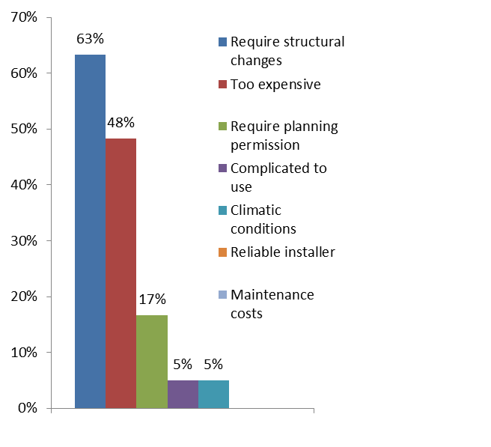
Figure 13: Reasons for rejecting RHC technologies

Out of the 69% of respondents who had heard of renewable energy technologies, the majority (51%) felt that solar water heating systems would be suitable for their premises. A further 22% considered biomass, followed by heat pumps at 16 %. Both district heating and geothermal systems did not feature highly in terms of the perceived suitability.

Overall, the suitability for ‘cooling’ based systems was lower than its heating equivalent. Ten per cent of the 69% felt that solar thermal systems would be suitable with biomass systems registered at 6%.

4.7 Willingness to pay

HEATING & DWH SYSTEMS COOLING SYSTEMS

Figure 14: Willingness to pay for RHC systems

Whilst fuel costs in RHC technologies tends to be lower but initial investment higher, 54 % of respondents stated that they were happy to make this initial investment. Out of those who were happy to make a higher initial investment, up to 86 % of respondents were willing to make an investment of up to 25% over the cost of fossil fuel based alternatives

Large scale industry report

Survey on industrial sector
The flow diagram in the execution of the survey is shown in Figure 19 and 20.
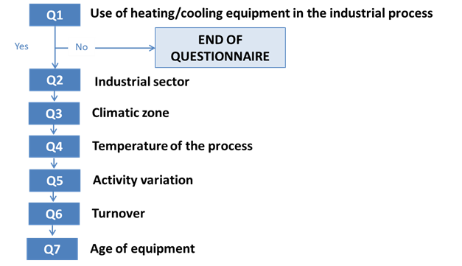
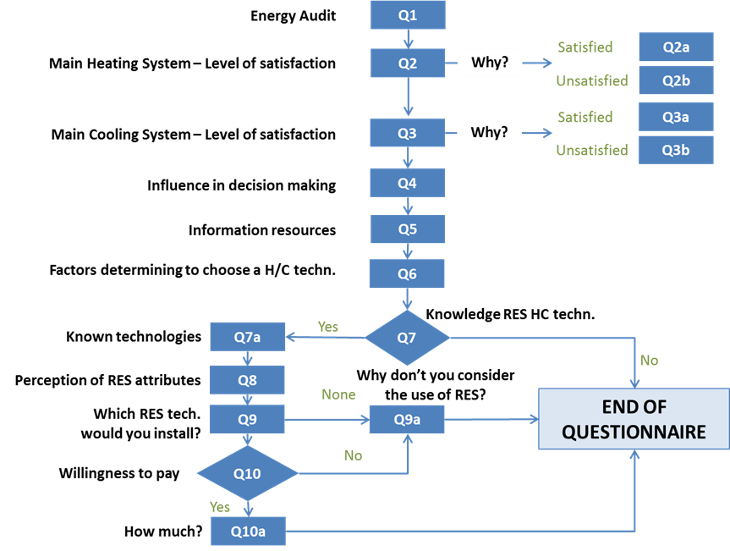

Main characteristics of the sample

For the UK industrial survey, a total of 120 interviews were conducted. The main characteristics of the survey have been outlined in the following charts:

USE OF HEATING ENERGY AUDIT Type of Activity 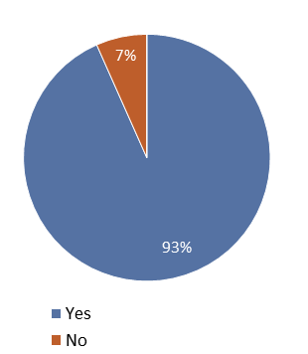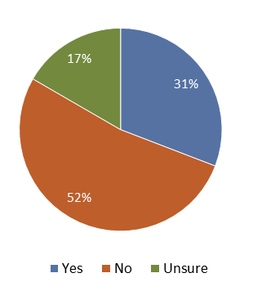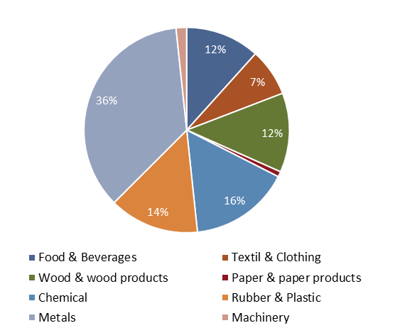

Figure 15: sample characteristics, large-scale industry

CURRENT HEAT AND COOLING SYSTEMS
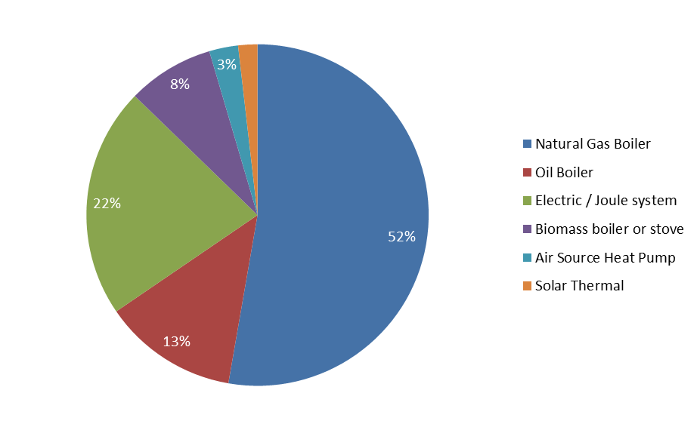
Figure 16: heating systems

The main industrial heating technology surveyed in the UK was natural gas boilers, accounting for 52% of total responses. This was followed by electric systems (including oil radiators), at 22% and heating oil boilers at 13%. The surveyed contribution of renewable energy technologies is negligible with only biomass accounting for a noticeable share at 8% - a pattern which was mirrored in the commercial survey results. It is worth noting that no district heating systems, either renewable or non-renewable were reported in the survey, which is a perhaps a reflection of the immaturity of this technology type within the UK.

Levels of satisfaction were high amongst the main recorded fossil fuel technologies: natural gas, heating oil boilers and electric systems; with average satisfaction level of 86% across these technologies. For biomass systems, the level of satisfaction was again high, accounting for 89% of total responses who selected this technology type.

With 54% of total responses, the reliability and safety of the technology was highlighted as the main reason end-users were satisfied with their system. At 17%, the second most cited reason was the appropriateness of the technology to fit the environmental conditions of the industrial process. However, environmental reasons per se featured poorly in the survey, accounting for 2% of total responses.

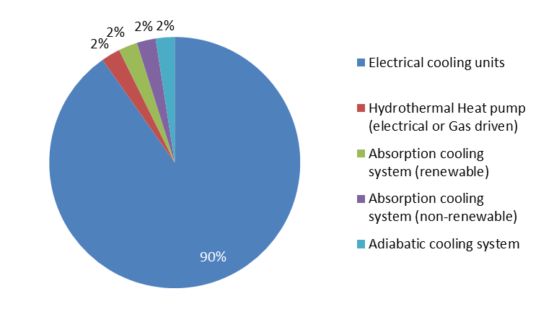
Figure 17: cooling systems

Of those who had reported using technologies for cooling purposes, the overwhelming majority (90%) used electric cooling units. Absorption cooling systems, both renewable and non-renewable, along with hydrothermal systems accounted for the remaining recorded technologies; however, there were no recorded instances of geothermal or air source heat pumps.

The level of satisfaction for electric cooling units was high, recorded at 92%. 48% of end-users felt that electric cooling systems provided the appropriate conditions for the industrial process, with a further 44% stating that the equipment was reliable and safe to use. The third most frequently cited factor was the cost and infrequency of maintenance needs.

INFORMATION RESOURCES
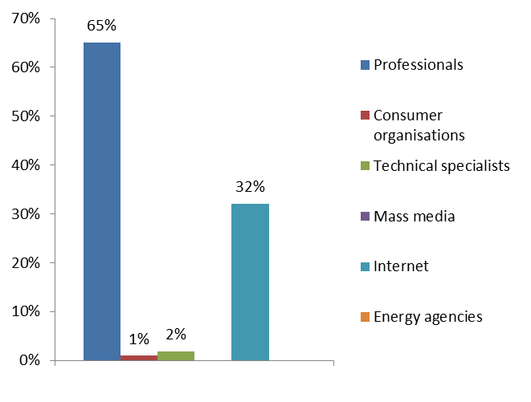
Figure 18: information resources

In terms of information sources, the majority (65%) of respondents stated that they would seek advice from professionals, including architects, specialised stores, installers and engineers. At 32%, the second most popular information source was the internet. Broken down by activity type, 66% of basic metal producers sought information from professionals; a pattern which was reflected in the chemical and rubber industry, at 74% and 73% respectively.

Key purchasing criteria
According to the survey, the key purchasing criteria (KPC) for heating and cooling systems for the UK’s industrial sector are as follows:

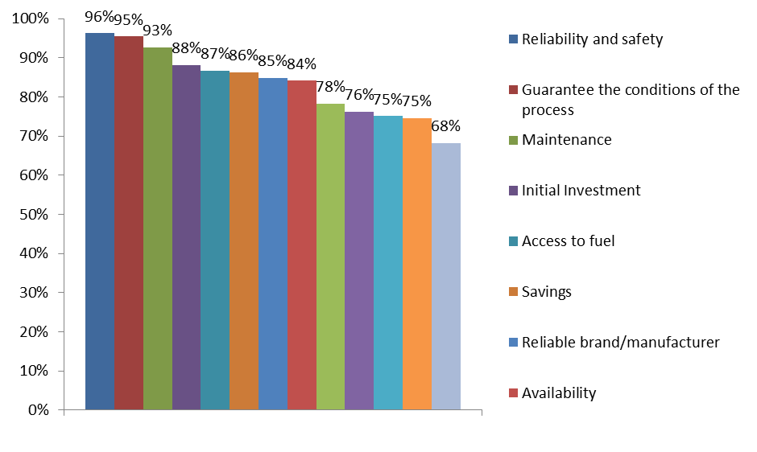
Figure 19: Key Purchasing Criteria
96% of respondents stated reliability and safety of the technology as the most important KPC, followed by guarantee in the conditions of the industrial process and maintenance costs. Recommendations from other industry professionals in similar industrial processes were ranked as the least important KPC. It is perhaps worth mentioning that this pattern was broadly reflected in the UK domestic survey.
The following table lists the key purchasing factors broken down by activity type. In reference to ‘environmental reasons’ there appears to be a higher concern from chemical and wood based industries.
 |  |  | Activity
KEY DECISION FACTORS | Answers | % | Metals | Chemicals | Machinery | Foods | Rubber & Plastics | Textiles | Wood
Guarantee the conditions of the process | 97 | 81% | 84% | 95% | 100% | 64% | 88% | 56% | 80%
Reliable and safe technology | 94 | 78% | 81% | 95% | 100% | 64% | 76% | 56% | 80%
No need of maintenance | 92 | 77% | 79% | 89% | 100% | 64% | 88% | 56% | 67%
Initial investment | 88 | 73% | 72% | 84% | 100% | 64% | 82% | 56% | 67%
Savings | 88 | 73% | 72% | 84% | 100% | 64% | 82% | 44% | 80%
Security of supply | 84 | 70% | 72% | 89% | 100% | 57% | 71% | 56% | 60%
Reliable brand/manufacturer | 82 | 68% | 63% | 89% | 100% | 50% | 82% | 44% | 73%
Availability of the technology | 79 | 66% | 67% | 89% | 100% | 50% | 71% | 56% | 47%
Knowledge of the technology | 75 | 63% | 63% | 84% | 100% | 50% | 71% | 33% | 53%
Architectural integration | 74 | 62% | 63% | 74% | 100% | 43% | 76% | 33% | 60%
Environmental reasons | 72 | 60% | 56% | 84% | 100% | 57% | 53% | 22% | 73%
Existence of energy labelling | 72 | 60% | 58% | 84% | 100% | 64% | 53% | 22% | 60%
Recommendation | 65 | 54% | 53% | 68% | 50% | 50% | 76% | 22% | 40%

Table 11: Key Decision Factors

Knowledge about RES
Out of those who took part in the survey 60% were found to know or heard about renewable energy technologies. With specific reference to activity type, awareness of renewable energy solutions was found to be highest amongst the wood and wood products sector, with 77 % of total responses. Conversely, the textiles industry found to have the lowest levels of end-user awareness. The ‘metals’ industry was found to have the most even distribution of awareness between ‘yes’ and ‘no’ answers.
 |  |  | Activity
Knowledge | Answers | % | Metals | Chemicals | Food | Rubber | Textiles | Wood
No | 44 | 40% | 46% | 37% | 38% | 35% | 60% | 23%
Yes | 67 | 60% | 54% | 63% | 62% | 65% | 40% | 77%

Table 12: Knowledge of RES technologies

Of those who had heard of RES (60%), awareness between the different technology types is listed as follows. Again it is worth noting that awareness for district heating technologies remains distinctly low, a reflection perhaps of the overall lack of penetration of this technology type within the UK.
Technology | Heating |  | Cooling
Solar Thermal | 96% |  | 69%
Biomass | 90% |  | 66%
Heat Pumps | 76% |  | 54%
Geothermal | 69% |  | 49%
District Heating | 24% |  | 24%

Table 13: awareness by technology type

perception of res TECHNOLOGIES

Attribute | Renewables | Non-renewables
Higher initial investment | 84% | 16%
Higher operation costs (maintenance and fuel) | 31% | 69%
Higher savings along the life expectancy of equipment | 89% | 11%
More eco-friendly | 98% | 2%
Higher working reliance | 65% | 35%
Higher visual impact and/or need of space to install/store fuel | 82% | 18%
Safer | 78% | 22%
More specialized installers | 85% | 15%

Table 14: Perception of RES technologies

Survey results found that renewable energy technologies were perceived to have higher initial investments but lower operational costs and savings along the life expectancy of the equipment. Renewables were recorded as having a higher working reliance and be safer to operate versus non-renewable alternatives. Conversely, renewable energy solutions were found to have a higher visual impact and require more specialised installers. This trends broadly reflect views found in the domestic section of the report.

Adequacy of Renewable Energy Solutions:

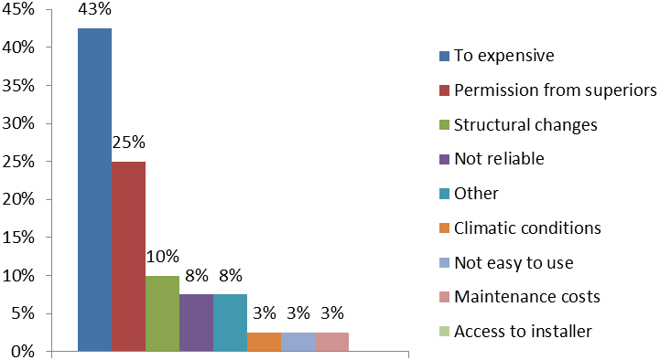
Figure 20: Adequacy of RES

Out of those who had heard of renewable heat or cooling technologies, 40% did not feel that a renewable energy solution would be appropriate for their industrial premises – the main justification was cost, followed by permission from superiors and necessary structural changes. Results for this question did not reveal any significant trend when broken down by industry type.

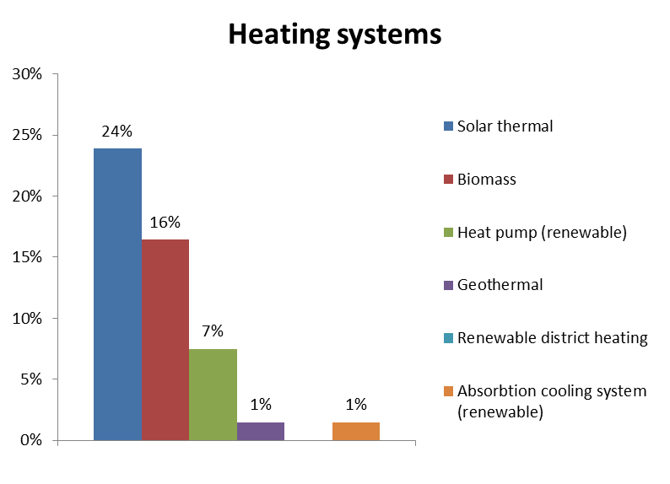
Figure 21: Considered suitability of technology – heating technologies

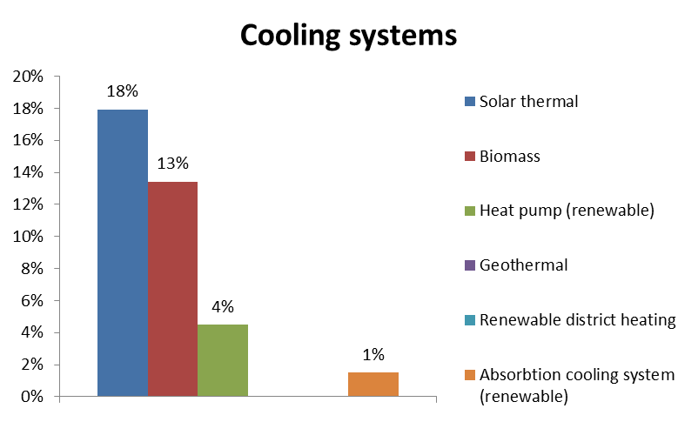
Figure 22: Considered suitability of technology – cooling technologies

For those who had heard of renewable energy solutions, 24 % considered solar thermal systems to be the most likely solution for their site. Biomass systems were ranked as the second most applicable system and heat pumps third. The applicability of cooling systems was lower than heating equivalent – however, in terms of order of preference, the list of technologies remains the same.

For the industrial survey, results revealed that 43% of respondents were willing to pay up to 25% extra initial investment costs versus fossil fuel based alternatives. However, above this figure the percentage fell to 9%.



The sole responsibility for the content of this [webpage, publication etc.] lies with the authors. It does not necessarily reflect the opinion of the European Union. Neither the EASME nor the European Commission are responsible for any use that may be made of
the information contained therein.

